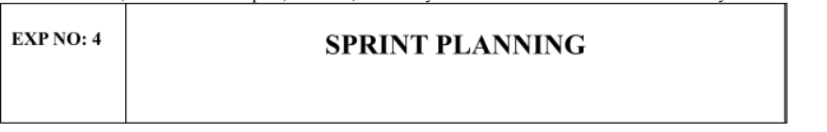
Aim:
To assign user story to specific sprint for the Music Playlist Batch Creator Project

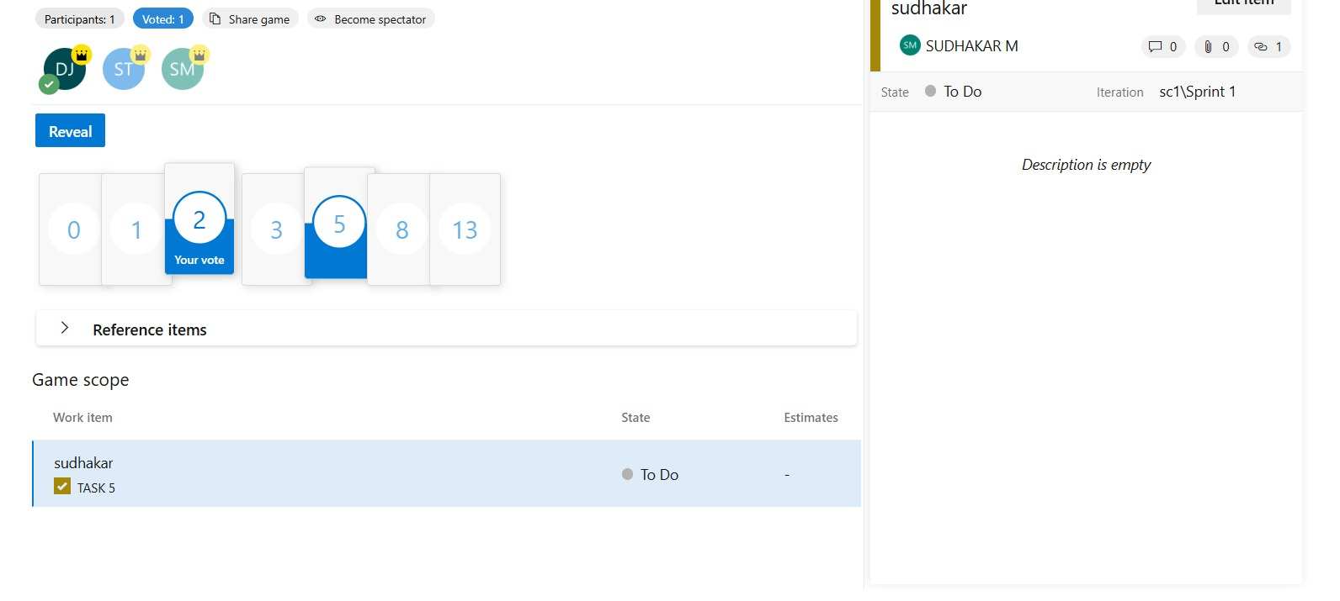

Result:
The Sprints are created for the Music Playlist Batch Creator Project

